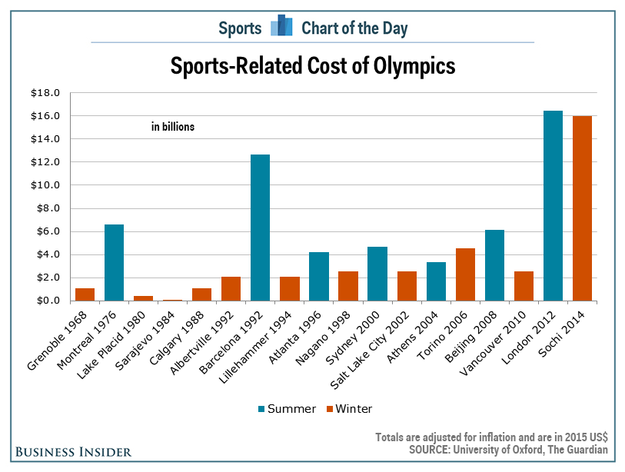
A study by Bent Flyvbjerg and Allison Stewart for the Saïd Business School at the University of Oxford looked at the sports-related cost and cost overrun for most Olympic games since 1968. From 1968 through 2010, the games had an average sports-related cost of $3.6 billion (inflation-adjusted). Then, all of a sudden, things took off. The last two Olympiads had an average cost of $16.2 billion.

To make matters worse, not a single Olympic games hit their budget with an average cost overrun of 167%. Only Beijing 2008 (4%) and Vancouver 2010 (17%) had cost overruns of less than 29%. In other words, it is easy to see why the Boston 2024 bid died when the mayor wouldn't immediately sign the host city contract that would have made the city responsible for cost overruns.

